

**Project 4: Medical Laboratory System Database Design and Implementation**

**Name : sama saeed moahmed**

**Id :221002117**

**Dr. Mohamed ELSayeh**

**Introduction**

This project aims to provide a comprehensive database system for a medical laboratory. It oversees critical entities such as laboratory employees, patients, medical tests, test outcomes, and test components. The system improves laboratory operations by arranging test supplies, assuring correct recording of findings, and allowing quick access to patient test data. Additionally, a user-friendly desktop application was created using Python and Tkinter, allowing users to interact with the system without the need for sophisticated instructions.

**Entities and Attributes**

* Laboratorian with attributes Laboratorian_ID (Primary Key), Name, Phone_Number, and Address.
* Patient with attributes Patient_ID (Primary Key), Name, Phone_Number, Address, Birth_Date, and Job.
* Component with attributes Component_ID (Primary Key), Name, Available_Quantity, and Minimum_Quantity.
* Medical_Test with attributes Test_ID (Primary Key), Name, and Price.
* There is a many-to-many relationship between Medical_Test and Component, represented by the associative entity Test_Component. It has a composite primary key consisting of Test_ID and Component_ID, both of which are foreign keys referencing Medical_Test and Component respectively.
* The Test_Result entity stores test results with attributes Result_ID (Primary Key), Test_ID (Foreign Key referencing Medical_Test), Patient_ID (Foreign Key referencing Patient), Laboratorian_ID (Foreign Key referencing Laboratorian), Date, and Result_Description.

**Relational Schema**

|  |  |  |
| --- | --- | --- |
| **Table** | **Attributes** | **Keys** |
| **Laboratorian** | Laboratorian_ID, Name, Phone_Number, Address | PK: Laboratorian_ID |
| **Patient** | Patient_ID, Name, Phone_Number, Address, Birth_Date, Job | PK: Patient_ID |
| **Component** | Component_ID, Name, Available Quantity, Minimum_Quantity | PK: Component_ID |
| **Medical_Test** | Test_ID, Name, Price | PK: Test_ID |
| **Test_Component** | Test_ID, Component_ID | PK: (Test_ID, Component_ID) FK: to Medical_Test and Component |
| **Test_Result** | Result_ID, Test_ID, Date, Patient_ID, Laboratorian_ID, Result | PK: Result_ID FK: to related tables |

**Test_Result Table**

* Result_ID (INT) — Primary Key
* Test_ID (INT) — Foreign Key: references Medical_Test(Test_ID)
* Patient_ID (INT) — Foreign Key: references Patient (Patient_ID)
* Laboratorian_ID (INT) — Foreign Key: references Laboratorian (Laboratorian_ID) Date (DATE)
* **Explanation:**

The schema structures the data into tables with well-defined relationships. Each table includes a primary key to uniquely identify records and foreign keys to connect related tables. The Test_Component table employs a composite key to manage the many-to-many relationship between tests and components. This design ensures accurate storage, updating, and retrieval of lab data while maintaining clear and consistent relationships.

**ER Diagram**

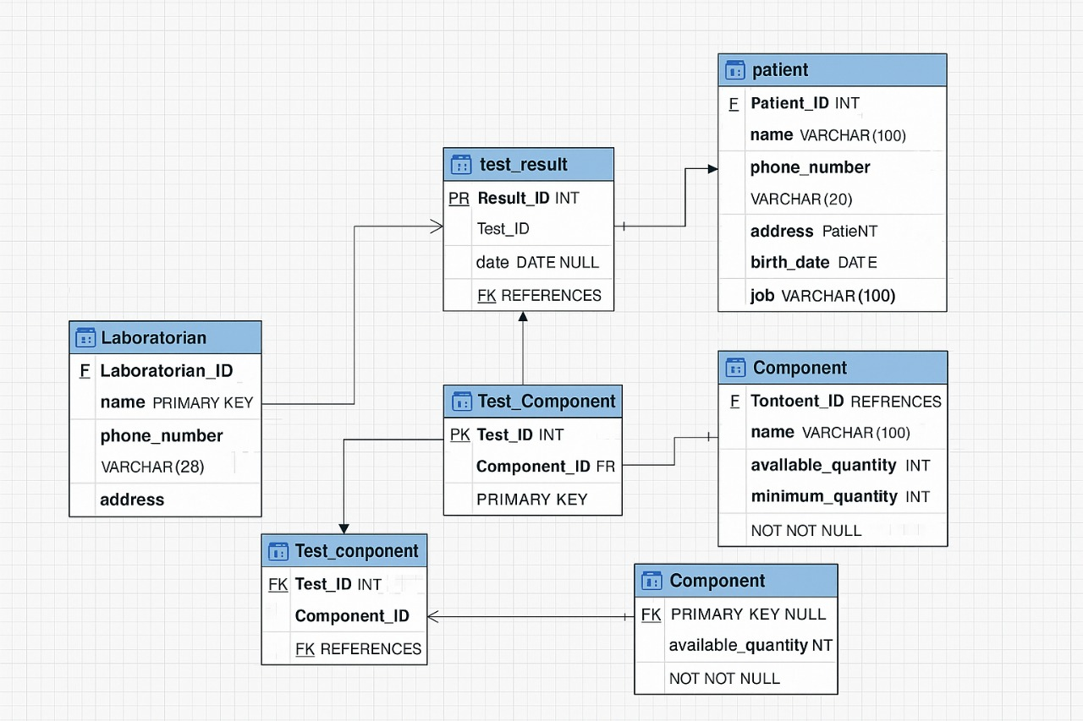The ER diagram shows relationships in the system.

* A one-to-many relationship between Laboratorian and Test Result (a laboratorian can perform many test results).
* A one-to-many relationship between Patient and Test Result (a patient can have multiple test results).
* A many-to-many relationship between Medical Test and Component, managed through the Test Component associative entity.
* Test Result requires total participation from Patient and Laboratorian. Components have partial participation with Medical Test.

**1)SQL Statements for Table Creation**

create database laborATION;

CREATE TABLE Laboratorian (

Laboratorian_ID INT PRIMARY KEY,

name VARCHAR (100) NOT NULL,

Phone_number VARCHAR (20),

address VARCHAR (255)

);

CREATE TABLE Patient (

Patient_ID INT PRIMARY KEY,

name VARCHAR(100) NOT NULL,

phone_number VARCHAR(20),

address VARCHAR(255),

birth_date DATE,

job VARCHAR (100)

);

CREATE TABLE Component (

Component_ID INT PRIMARY KEY,

name VARCHAR(100) NOT NULL,

available_quantity INT NOT NULL,

minimum_quantity INT NOT NULL

);

CREATE TABLE Medical_Test (

Test_ID INT PRIMARY KEY,

name VARCHAR(100) NOT NULL,

price DECIMAL(10,2) NOT NULL

);

CREATE TABLE Test_Component (

Test_ID INT,

Component_ID INT,

PRIMARY KEY (Test_ID, Component_ID),

FOREIGN KEY (Test_ID) REFERENCES Medical_Test(Test_ID),

FOREIGN KEY (Component_ID) REFERENCES Component(Component_ID)

);

**2)CREATE TABLE Test_Result (**

Result_ID INT PRIMARY KEY,

Test_ID INT,

date DATE NOT NULL,

Patient_ID INT,

Laboratorian_ID INT,

result VARCHAR (255), FOREIGN KEY (Test_ID) REFERENCES Medical_Test(Test_ID), FOREIGN KEY (Patient_ID) REFERENCES Patient (Patient_ID),

FOREIGN KEY (Laboratorian_ID) REFERENCES Laboratorian (Laboratorian_ID)

);

**Explanation:**

The SQL statements create tables for the medical lab system, with each table having a primary key to uniquely identify records and maintain organization. The Test_Component table uses a composite primary key consisting of Test_ID and Component_ID to represent the many-to-many relationship between medical tests and components. Foreign keys are implemented to connect related tables and ensure referential integrity. Additionally, important fields are defined as NOT NULL to guarantee that essential data is always provided.

**3).Sample Data Insertion**

INSERT INTO Laboratorian VALUES

(1, 'Yousef Kamal', '0155555555', 'Cairo'),

(2, 'Lina Farouk', '0123456789', 'Alexandria'),

(3, 'Samir Nabil', '0112345678', 'Giza'),

(4, 'Dina Youssef', '0109876543', 'Cairo'),

(5, 'Hassan Adel', '0133333333', 'Tanta'),

(6, 'Mona Sherif', '0144444444', 'Mansoura'),

(7, 'Omar Khaled', '0156666666', 'Cairo'),

(8, 'Rania Ibrahim', '0167777777', 'Alexandria'),

(9, 'Tariq Sami', '0178888888', 'Cairo'),

(10, 'Nahla Samir', '0189999999', 'Giza');

INSERT INTO Patient VALUES

(1001, 'Sara Ibrahim', '0191111111', 'Cairo', '1983-02-14', 'Architect'),

(1002, 'Ahmed Mostafa', '0112222222', 'Alexandria', '1989-07-21', 'Engineer'),

(1003, 'Mona Khalil', '0123333333', 'Giza', '1979-12-01', 'Teacher'),

(1004, 'Hany Nasser', '0134444444', 'Cairo', '1985-04-25', 'Pharmacist'),

(1005, 'Laila Farid', '0145555555', 'Tanta', '1993-11-30', 'Nurse'),

(1006, 'Khaled Salah', '0156666666', 'Mansoura', '1982-09-10', 'Lawyer'),

(1007, 'Nada Samir', '0167777777', 'Cairo', '1986-03-05', 'Accountant'),

(1008, 'Tamer Maher', '0178888888', 'Alexandria', '1994-06-18', 'Designer'),

(1009, 'Amira Adel', '0189999999', 'Giza', '1977-08-22', 'Doctor'),

(1010, 'Omar Khaled', '0190000000', 'Cairo', '1991-01-30', 'Student');

INSERT INTO Component VALUES

(1, 'Serum Separator Tube', 60, 15),

(2, 'Blood Glucose Reagent', 25, 20),

(3, 'Hemoglobin A1c Reagent', 50, 30),

(4, 'Glass Microscope Slides', 55, 20),

(5, 'Sterile Urine Cups', 40, 20),

(6, 'Chemical Reagent X', 18, 12),

(7, 'Chemical Reagent Y', 10, 15),

(8, 'Plastic Test Tubes', 45, 20),

(9, 'Sterile Alcohol Swabs', 75, 40),

(10, 'Disposable Gloves', 110, 60);

INSERT INTO Medical_Test VALUES

(101, 'Complete Blood Count', 180.00),

(102, 'Fasting Blood Sugar', 130.00),

(103, 'Urine Routine Test', 110.00),

(104, 'Liver Enzymes Test', 210.00),

(105, 'Kidney Profile', 195.00),

(106, 'Cholesterol Test', 170.00),

(107, 'Thyroid Panel', 175.00),

(108, 'Vitamin B12 Test', 165.00),

(109, 'COVID-19 Antigen', 320.00),

(110, 'Electrolytes Test', 150.00);

INSERT INTO Test_Component VALUES

(101, 1),

(101, 3),

(102, 2),

(103, 5),

(104, 6),

(105, 7),

(106, 8),

(107, 9),

(108, 10),

(109, 4),

(110, 3);

INSERT INTO Test_Result VALUES

(1, 101, '2025-01-15', 1001, 2, 'CBC within normal range'),

(2, 102, '2025-02-10', 1002, 3, 'Slightly elevated blood sugar'),

(3, 103, '2025-03-05', 1003, 4, 'Urine test normal'),

(4, 104, '2025-01-25', 1004, 5, 'Mildly elevated liver enzymes'),

(5, 105, '2025-02-15', 1005, 6, 'Kidney function normal'),

(6, 106, '2025-03-20', 1006, 7, 'Cholesterol high'),

(7, 107, '2025-01-30', 1007, 8, 'Normal thyroid levels'),

(8, 108, '2025-02-28', 1008, 9, 'Vitamin B12 deficiency'),

(9, 109, '2025-03-15', 1009, 10, 'COVID-19 antigen negative'),

(10, 110, '2025-01-10', 1010, 1, 'Electrolyte levels normal');

**Explanation:**

These SQL insertion commands populate each table with realistic sample data, enabling effective testing of the database. Including at least ten records per table provides sufficient data diversity to thoroughly evaluate queries and system functionality.

**4).Example Queries**

SELECT DISTINCT p.name

FROM Patient p

JOIN Test_Result tr ON p.Patient_ID = tr.Patient_ID

JOIN Medical_Test mt ON tr.Test_ID = mt.Test_ID

WHERE mt.name = 'Complete Blood Count'

AND tr.date >= DATE_SUB(CURDATE(), INTERVAL 1 YEAR);

SELECT name, available_quantity, minimum_quantity

FROM Component

WHERE available_quantity < minimum_quantity;

SELECT p.name, SUM(mt.price) AS total_paid

FROM Patient p

JOIN Test_Result tr ON p.Patient_ID = tr.Patient_ID

JOIN Medical_Test mt ON tr.Test_ID = mt.Test_ID

WHERE p.Patient_ID = 1001

AND tr.date >= DATE_SUB(CURDATE(), INTERVAL 3 YEAR)

GROUP BY p.Patient_ID;

SELECT p.name, SUM(mt.price) AS total_paid

FROM Patient p

JOIN Test_Result tr ON p.Patient_ID = tr.Patient_ID

JOIN Medical_Test mt ON tr.Test_ID = mt.Test_ID

WHERE p.Patient_ID = 12527

AND tr.date >= DATE_SUB(CURDATE(), INTERVAL 3 YEAR)

GROUP BY p.Patient_ID;

**Conclusion**

In conclusion, designing a well-structured database with clear relationships, proper keys, and realistic sample data is essential for building a reliable and efficient medical lab system. This foundation ensures data integrity, supports accurate testing, and enables smooth operation of the system’s functionalities.